File name: dmarc.py (118 lines of code)

import dns.resolver
import json
from rich.console import Console
from rich.table import Table

console = Console()

# ---------------- DNS Check Functions ---------------- #

def get_dmarc(domain):
try:
answers = dns.resolver.resolve(f"_dmarc.{domain}", "TXT")
for r in answers:
text = r.to_text().strip('"')
if "v=DMARC1" in text:
policy = "none"
for part in text.split(";"):
if part.strip().startswith("p="):
policy = part.strip()[2:]
return True, text, policy
return False, None, None
except Exception:
return False, None, None

def get_spf(domain):
try:
answers = dns.resolver.resolve(domain, "TXT")
for r in answers:
text = r.to_text().strip('"')
if "v=spf1" in text:
warning = "Permissive SPF (all)" if "+all" in text or text.split()[-1] in ["~all","?all"] else None
return True, text, warning
return False, None, None
except Exception:
return False, None, None

def get_dkim(domain, selectors):
for selector in selectors:
try:
answers = dns.resolver.resolve(f"{selector}._domainkey.{domain}", "TXT")
for r in answers:
text = r.to_text().strip('"')
if "v=DKIM1" in text:
return True, text, selector
except Exception:
continue
return False, None, None

# ---------------- Output ---------------- #

def print_results(domain, dmarc_res, spf_res, dkim_res):
dmarc_exists, dmarc_text, dmarc_policy = dmarc_res
spf_exists, spf_text, spf_warn = spf_res
dkim_exists, dkim_text, dkim_selector = dkim_res

table = Table(title=f"Email Security Audit for {domain}")
table.add_column("Record", style="cyan", no_wrap=True)
table.add_column("Status", style="magenta")
table.add_column("Details / Warnings", style="yellow")

table.add_row("DMARC", "[green]Exists[/green]" if dmarc_exists else "[red]Missing[/red]",
f"Policy: {dmarc_policy}\n{text_wrap(dmarc_text,50)}" if dmarc_exists else "")
table.add_row("SPF", "[green]Exists[/green]" if spf_exists else "[red]Missing[/red]",
f"{text_wrap(spf_text,50)}" + (f"\n⚠ {spf_warn}" if spf_warn else "") if spf_exists else "")
table.add_row("DKIM", "[green]Exists[/green]" if dkim_exists else "[red]Missing[/red]",
f"Selector: {dkim_selector}\n{text_wrap(dkim_text,50)}" if dkim_exists else "")

score = sum([dmarc_exists, spf_exists, dkim_exists])
table.caption = f"Overall Email Security Score: {score}/3"
console.print(table)

def text_wrap(text, width=60):
import textwrap
if text:
return "\n".join(textwrap.wrap(text, width=width))
return ""

# ---------------- Interactive CLI ---------------- #

def interactive_cli():
console.print("[bold cyan]Welcome to the Email Security Audit Tool[/bold cyan]\n")

results_list = []

while True:
domain_input = input("Enter a domain (or type 'exit' to quit): ").strip()
if domain_input.lower() == "exit":
break

selectors_input = input("Enter DKIM selectors separated by space (press Enter for 'default'): ").strip()
selectors = selectors_input.split() if selectors_input else ["default"]

json_input = input("Do you want to export results to JSON? (y/n): ").strip().lower()
export_json = json_input == "y"

# Run checks
dmarc_res = get_dmarc(domain_input)
spf_res = get_spf(domain_input)
dkim_res = get_dkim(domain_input, selectors)

print_results(domain_input, dmarc_res, spf_res, dkim_res)

results_list.append({
"domain": domain_input,
"DMARC": {"exists": dmarc_res[0], "record": dmarc_res[1], "policy": dmarc_res[2]},
"SPF": {"exists": spf_res[0], "record": spf_res[1], "warning": spf_res[2]},
"DKIM": {"exists": dkim_res[0], "record": dkim_res[1], "selector": dkim_res[2]},
"score": sum([dmarc_res[0], spf_res[0], dkim_res[0]])
})

if export_json:
with open("email_audit_results.json", "w") as f:
json.dump(results_list, f, indent=4)
console.print("[bold green]Results exported to email_audit_results.json[/bold green]")

console.print("\n[bold yellow]--- Scan Complete ---[/bold yellow]\n")

interactive_cli()

- Run the file
- Enter the domain (gmail.com, yahoo.com, outlook.com)
- Enter default or selector1 or selector2
- Y
- Output will be generated
- Exit
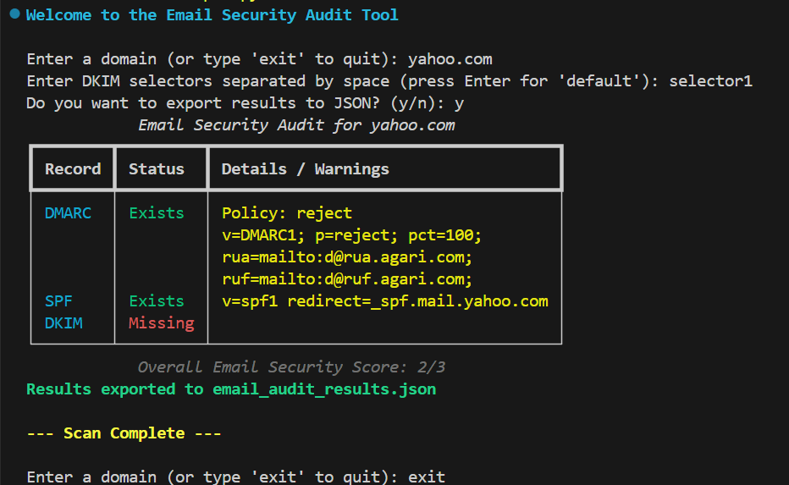

File name: dmarc-check.py (76 lines of code)

import argparse
import dns.resolver

print("Author: iamsurve")

def check_dmarc(domain):
"""
Check if the DMARC record exists for the given domain.
"""
try:
dmarc_record = dns.resolver.resolve('_dmarc.' + domain, 'TXT')
for record in dmarc_record:
if 'v=DMARC1' in record.to_text():
return True
return False
except Exception as e:
print(f"[!] Error checking DMARC record for domain '{domain}': {e}")
return False

def check_spf(domain):
"""
Check if the SPF record exists for the given domain.
"""
try:
spf_record = dns.resolver.resolve(domain, 'TXT')
for record in spf_record:
if 'v=spf1' in record.to_text():
return True
return False
except Exception as e:
print(f"[!] Error checking SPF record for domain '{domain}': {e}")
return False

def check_dkim(domain, selector):
"""
Check if the DKIM record exists for the given domain and selector.
"""
try:
dkim_record = dns.resolver.resolve(f'{selector}._domainkey.{domain}', 'TXT')
for record in dkim_record:
if 'v=DKIM1' in record.to_text():
return True
return False
except Exception as e:
print(f"[!] Error checking DKIM record for domain '{domain}' and selector '{selector}': {e}")
return False

def main():
parser = argparse.ArgumentParser(description='Check DMARC, SPF, and DKIM records for multiple domains.')
parser.add_argument('domains', type=str, nargs='+', help='The domains to check')
parser.add_argument('--selector', type=str, default='default', help='The DKIM selector to check (default: default)')

args = parser.parse_args()

for domain in args.domains:
print(f"Checking DMARC record for domain '{domain}'...")
if check_dmarc(domain):
print("[+] DMARC record exists.")
else:
print("[-] DMARC record does not exist.")

print(f"Checking SPF record for domain '{domain}'...")
if check_spf(domain):
print("[+] SPF record exists.")
else:
print("[-] SPF record does not exist.")

print(f"Checking DKIM record for domain '{domain}' and selector '{args.selector}'...")
if check_dkim(domain, args.selector):
print("[+] DKIM record exists.")
else:
print("[-] DKIM record does not exist.")

if __name__ == "__main__":
main()

- python dmarc-check.py
- python dmarc-check.py gmail.com (Asking for domain name)

